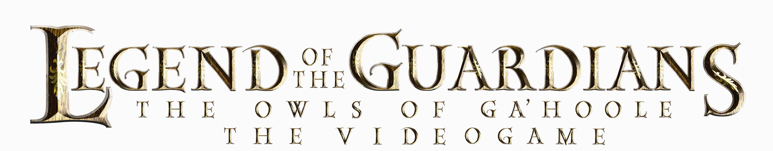

FACT SHEET

RELEASE DATE: September 29th, 2010

PUBLISHER: Warner Bros. Interactive Entertainment

**DEVELOPER:** Krome Studios (Xbox 360, Wii, PS3) Tantalus Media (DS)

**OFLC RATING:** G

**GENRE:** Flight Action

**PLATFORMS:** Xbox 360, PS3, Wii, DS

**PLAYERS:** Single Player

**PRODUCT OVERVIEW:**

***Legends of the Guardians: The Owls of Ga’Hoole – The Videogame***, is a stunning action flight game set in an epic fantasy world based on the bestselling book series by author Kathryn Lasky, with an action-packed storyline that parallels the plot of the upcoming 3D fantasy family adventure film *Legend of the Guardians: The Owls of Ga’Hoole*.

In ***Legends of the Guardians: The Owls of Ga’Hoole – The Videogame***, a young owlet named Soren arrives at the Great Ga’Hoole Tree and tells of his escape from the evil Pure Ones, revealing a new threat to the owl kingdoms.  Players take on the role of Shard, a promising young Guardian, setting out on a secret mission to reveal the truth and uncover the sinister plans of the Pure Ones.

Kids will assemble an unlikely band of heroes as they take on the role of a Guardian, a winged warrior and protector of the owl world. As Shard, players take the fight against evil to the air, armed with battle claws and aided by trustworthy allies. Travelling through the owl kingdoms, fans will have a chance to experience the unique history and lands of Ga’Hoole in the heat of battle. Can you uncover the Pure One plot before it is too late?

**PRODUCT FEATURES:**

* **World of Ga’Hoole:** Explore the world of the animated film through the original, action-packed storyline with full 360 degree flight mechanics in over 22 missions across 5 unique worlds
* **Intuitive Gameplay:** Easy pick-up-and-play experience allows younger players to easily master flying through the air, picking up objects, and engaging in mid-air combat. Deeper combat systems will engage older players with melee combos
* **Mid Air Combat:** Battle owls and other enemies in mid air utilizing the robust combat system which enables players to lock-on targeting and chain attacks
* **Aerial Allies:** Command your wingmen to attack enemies and gain the upper hand in squad-based flight missions
* **Customizable Characters:** Upgrade your character’s stats and abilities through the course of the game by unlocking new armour sets, each with their own advantages
* **Enchanting Environments:** Experience stunning visuals and environments based on assets from the film
* **Unique Abilities:** Choose from four different species: Horned, Barn, Great Gray, or Spotted! Each owl species provides a different set of initial abilities, providing a slightly different gameplay experience(console only)

**CONTACTS:**

Joel Graham Greg Vekiarellis

Warner Bros. Interactive Entertainment One Green Bean

+61 2 9495 3139 02 80201804

[joel.graham@warnerbros.com](mailto:joel.graham@warnerbros.com) [greg@onegreenbean.com.au](mailto:craig@fortyseven.com)